

SUPERIOR UNIVERSITY LAHORE
GOLD CAMPUS

NAME: MUHAMMAD MOIZ RAZA
ROLL NO: SU92-BSAIM-F24-061
PROGRAM: ARTIFICIAL INTELLIGENCE
SEMESTER: 3rd SEMESTER
SECTION: BSAI-3A
SUBJECT: ARTIFICIAL INTELLIGENCE

Submission Title: PROJECT
- COURSE PREDICTOR
Submitted To: Sir RASHIK ALI

1. Introduction
The aim of this project is to build a Course Recommendation System that suggests the most suitable course to a user based on their personal preferences. The system uses Machine Learning to make accurate predictions.
The recommendation is based on the following user inputs:
- Interests
- Category
- Preferred Difficulty Level
- Past Experience
- Preferred Language
The output of the model is the Recommended Course.

2. Dataset Description
Dataset File Name: recomdata.csv
Total Records: 5000
Total Columns: 6

Dataset Properties:
- All columns are of categorical (object) type
- No missing (null) values
- Dataset is clean and well-structured

3. Libraries Used
The following Python libraries were used in this project:
Library | Purpose
pandas | Data loading and manipulation
matplotlib | Data visualization
seaborn | Heatmap and correlation visualization
scikit-learn | Model training, preprocessing, and evaluation
Pickle | Saving the trained model

4. Data Loading
The dataset was loaded using pandas:
- df.head()
- df.tail()
- df.shape
- df.columns
- df.describe()
- df.info()
These functions helped in understanding:
- Number of rows and columns
- Data types of each column
- Summary statistics
- Overall structure of the dataset

5. Exploratory Data Analysis (EDA)
EDA was performed to understand the data distribution and relationships between features.

Purpose of EDA:
- To understand data patterns
- To analyze feature relationships
- To detect outliers
- To study data distribution

6. Data Preprocessing

Handling Missing Values
Although the dataset had no missing values, a function was created to handle missing values in case they appear in future

Encoding Categorical Data
Since Machine Learning models cannot work with text data directly, Label Encoding (Factorization) was applied

7. Feature and Target Selection
X = df.drop("recommended_course", axis=1)
y = df["recommended_course"]
X → Input Features
y → Output / Target Variable

8. Train-Test Split
The dataset was divided into training and testing sets to evaluate model performance
X_train, X_test, y_train, y_test = train_test_split(
X, y, test_size=0.2, random_state=42
)
80% data used for training
20% data used for testing

9. Model Used

Random Forest Classifier
Random Forest is an ensemble learning algorithm that combines multiple decision trees to improve prediction accuracy and reduce overfitting.

10. Prediction and Model Evaluation
- The model achieved high accuracy
- The predictions are reliable and stable
- The model generalizes well on unseen data

11. Model Saving
The trained model was saved using pickle so it can be reused later for deployment

12. FLASK IMPLIMENTATION
After train a model. Now we make a front end on flask with stylish look in which we enter our experience and interest then we get our recommended course for GUI we use flask.
STRUCTURE:
- app.py
- Template folder
- Index.html
- Index.html
- Result.html
- Static folder
- Style.css
- Script.js
- Requirements.txt
- Model_train.ipynb file
- Model.pkl
- Venv file

App.py: This is our main entry point of flask application
Templete/index.html: This is our home page of website
Templete/result.html: this is another page in which our predicted score shows
Style.css:This is my css file of Gui in which all style and theme of my Website Written
Requirement.txt: I this file our libraries which is use in our project is written it is use to install libraries in virtual env
Model_train.ipynb file: In this File we train our model from dataset
Model.pkl: In this file our trained model is saved.

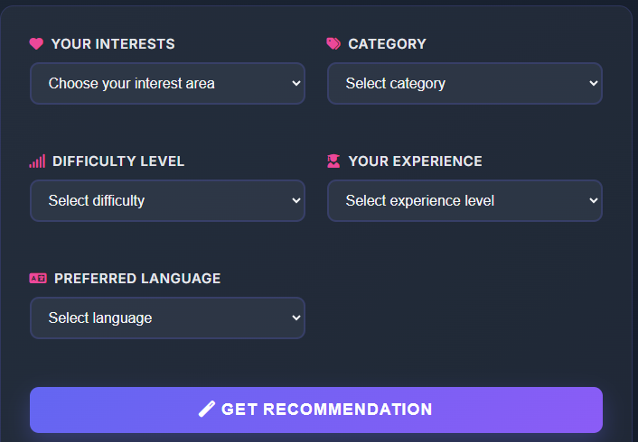

The recommendation is based on the following user inputs:
- Interests
- Category
- Preferred Difficulty Level
- Past Experience
- Preferred Language

–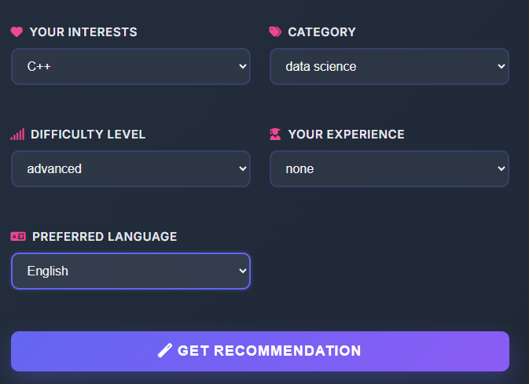

We put all his fields that is necessary for recommendation
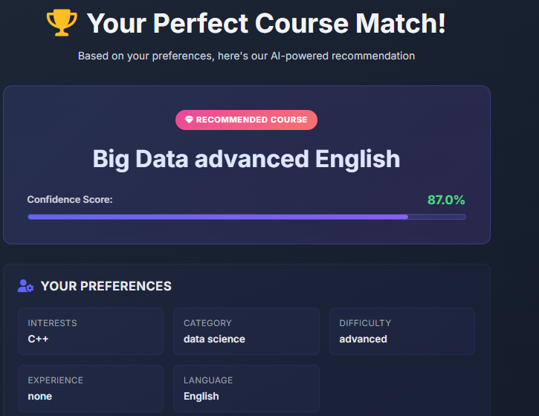

This is result page of our project in which he recommend best suitable course.

Result
• The dataset was clean and well-balanced.
• Proper EDA improved understanding of the data.
• Label encoding successfully converted categorical data.
• Random Forest performed very well with high prediction accuracy.
• The model was successfully trained and stored for future use.
Future Scope
The system can be further improved by:
- Using Deep Learning models
- Deploying it as a web application using Flask or Streamlit
- Adding real-time user feedback
- Using collaborative filtering
- Connecting it to a real online course database

Conclusion
- This project successfully demonstrates how Machine Learning can be used to build an intelligent Course Recommendation System. The system analyzes user preferences and suggests the most suitable course using a trained Random Forest model.
- All key machine learning steps were implemented:
- Data loading
- Exploratory Data Analysis
- Data preprocessing
- Train-test split
- Model training
- Model evaluation
- Model saving
- This system can be effectively used in:
- E-learning platforms
- Online education portals
- Skill development websites

THE END

